IS 312 Web Design and Programming: TypeScript (TS) for Modern Web Application
HOS01A: Installing Node.js, NPM, and TypeScript in VSCode

9/18/2023, Reviewed by Ajay Naik
1/04/2024, Reviewed by Lakshmipathi Machineni
10/04/2024, Reviewed by Shahid Khan

School of Technology & Computing (STC)
City University of Seattle (CityU)

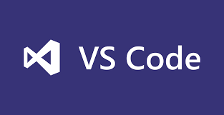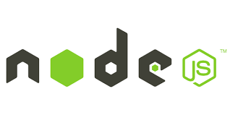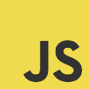

Before You Start
- If you already finished this VSCode(VSC) module through any CityU Department of Technology and Computing courses, just skim through the steps to verify you have the following tool(s) set up for the future group activities in the class.
  - Node.js
  - NPM
- Version numbers may not be the latest release shown in this document. However, we encourage the students to install the latest official release version or long-term support version (LTS).
- This document primarily targets Windows OS users. MacOS users may require additional resources to complete the requirement. Please contact the instructor for further assistance.
- This group activity shows step-by-step (i.e. cookbook style) tutorial and students are encouraged to make an educational judgement to complete each step. If not clear, please contact the instructor for clarification.
- For your working directory, use your course number (e.g. IS312). This tutorial may use a different course number as an example.

Learning Outcomes
- Installing Node.js
- Running Node.js
- Verifying Node Package Manager (npm) installation

Installing Node.js
- Visit https://nodejs.org/en/

Note: For selecting a different OS click on the downloads tab.

- Download the installation file for your operating system. At the time of writing, “node-v20.18.01 ” is the latest LTS.

- Start the installation process for Node.js.

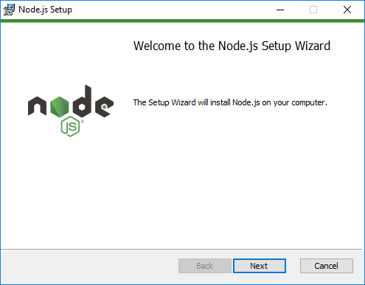

Running Node.js
- Open VS code and then open the folder IS312 on your local machine

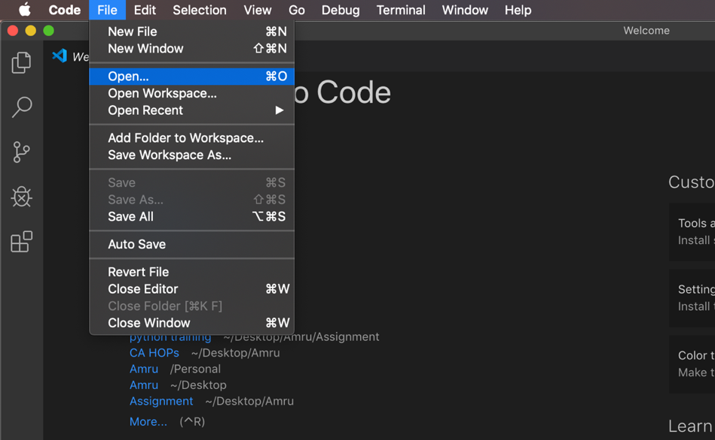

- Inside IS312, check if your firstnamelastname folder is available, if not create the folder and navigate inside it. Open the terminal and type the following commands.

- Check the version of Node.js by typing the following and confirm the version number:

Note: If you face an issue like “You cannot run this script on the current system”.
- Window’s User: Open Command Prompt as Administrator and execute command as given.
- Unix’s User: use sudo before every command.
>>> node --version

Also, type node at the prompt to verify if the Node.js is integrated to VSC (see below).
>>> node

>>> console.log('Node is up and running!');

To exit type Ctrl+c twice

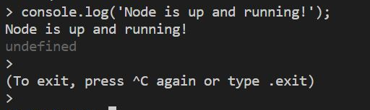

Checking for Node Package Manager (NPM)
Note: Installing Node.js already includes NPM.

- Check the version of npm by typing the following:

>>> npm --version

Installing TypeScript Transpiler

- TypeScript transpiler can be installed via NPM, and we’ll install the transpiler globally.
And then, we will verify the version of the TypeScript.
>>> npm install -g typescript

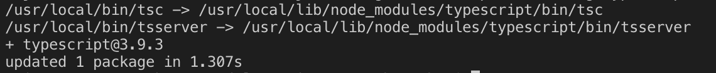
>>> tsc –version

